Assignment: Ethernet Standards and Specification

RJ-45 Connector Pin Layout
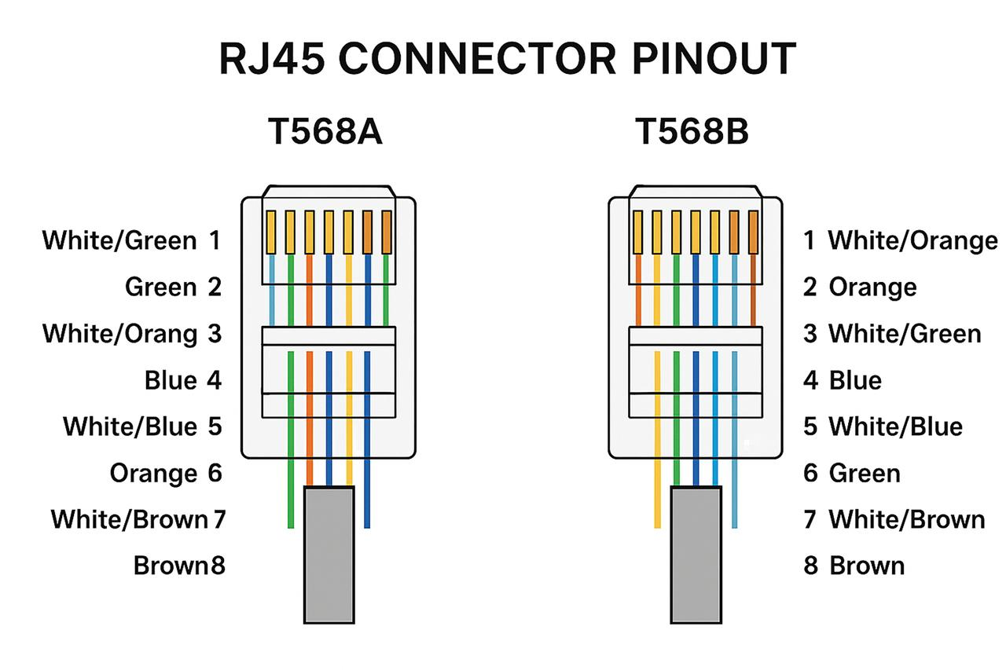
Pin | T568A | T568B
1 | White/Green | White/Orange
2 | Green | Orange
3 | White/Orange | White/Green
4 | Blue | Blue
5 | White/Blue | White/Blue
6 | Orange | Green
7 | White/Brown | White/Brown
8 | Brown | Brown
T568A uses the green pair on pins 1-2 while T568B uses the orange pair on pins 1-2. Both provide identical performance.
Insert the RJ-45 T568A/T568B diagram image from the chat here.

2. Ethernet Standards Comparison
Feature | 10BASE-T | 100BASE-TX | 1000BASE-T
Speed | 10 Mbps | 100 Mbps | 1000 Mbps
Cable | Cat3/Cat5 | Cat5+ | Cat5e/Cat6+
Max Length | 100 m | 100 m | 100 m
Connector | RJ-45 | RJ-45 | RJ-45

3. Connecting Two Laptops
Traditionally, use a crossover Ethernet cable because it swaps the transmit and receive pairs, allowing two similar devices to communicate directly. Modern laptops usually support Auto-MDI/MDIX, so either cable may work, but crossover is the standard answer.

4. Devices Using Ethernet
Device | Likely Standard | Reason
Desktop PC | 1000BASE-T | High-speed networking
Wi-Fi Router | 1000BASE-T | Gigabit LAN ports
Network Printer | 100BASE-TX | Sufficient bandwidth

